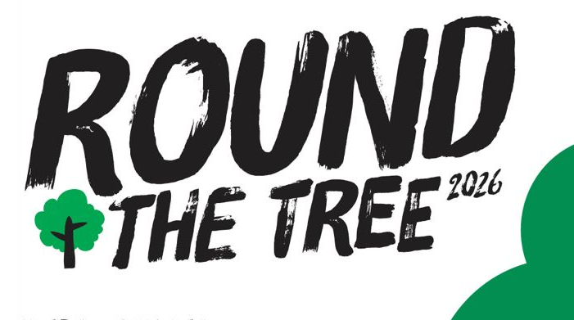

Proudly Presents…
Friday 8th May 2026

A fantastic multi-terrain challenge starting and finishing in Great Torrington Town Square – part of the town’s historic Mayfair celebrations.
Senior race 2.75 miles |  | Race Start Times
Junior race 1.75 miles (Min age 11 yrs) |  | Registration from 5.30pm
Adults: £9 Unaffiliated / £7 affiliated |  | 6:45 pm | All Year 7/8 and 9/10
Juniors: £3 / Walkers £9 |  | 6:50 pm | Walkers
 |  | 7:15 pm | Senior Female
 |  | 7.30 pm | Senior Male
 |  | Fun runners will run in Senior M/F races
1st, 2nd & 3rd | Y7/8 Boys and girls | - Enter on the day.
1st, 2nd & 3rd | Y9/10 Boys and girls | - Enter in Whiskers Pet Shop, Duffy’s or Torrington Jewellers  - 2 Castle Street, Torrington
1st, 2nd & 3rd | Senior Male and female | TAAC thanks Nigel & Diana of Oak Park Farm for their support in encouraging us to keep this traditional Torrington race alive by allowing access to the tree.  Please run with care and respect at all times and follow the instructions from race briefings and marshals.
1st prize | Vets >40, >50 and >60 Male and Female
All | Medal for all finishers
Watch out | Spot prizes, fancy dress and team
BIB
TAAC RTT 2026 ENTRY INFORMATION: PLEASE PRINT CLEARLY
Name* .................................................................... Email ...............................................................................
Address........................................................................................... Postcode…………………………………………
€ Male  € Female | € Senior  € Vet | € Y7/8  € Y9/10 | € Fun runner/Team  € Walker

Club/team......................................................................................UKA….………………………..……

DOB*................................................................ Age on race day*…………………………………………………. *Mandatory info
Any medical conditions we should be aware of? * YES (please write clearly overleaf) / NO
Competitors will be given their race numbers on the day.
I understand that I take part in Round the Tree entirely at my own risk and agree not to hold Torrington AAC or any person involved in the organisation responsible in any way for injury or loss as a result of my participation. TAAC regret that this race is not suitable for wheelchairs. I understand that Round the Tree is a challenging off-road event over difficult terrain, and I confirm I have the required level of fitness to complete the course. I understand that photographs will be taken during the race and may appear on TAAC website and Facebook page. I understand that my name may appear in entry and results lists on TAAC website and Facebook/Instagram. TAAC are not providing water refreshments on or at the end of the course (there are plenty of shops in the town centre). TAAC RESERVE THE RIGHT TO WITHDRAW RUNNERS FROM THE RACE WHO HAVE NOT MADE SUFFICIENT PROGRESS THROUGH CHECKPOINTS. RACE TIME TO BE CUT OFF AFTER 60MINS DUE TO PANNIER MARKET CLOSING AT 8.30PM.
Signed (parent or guardian if under 16):………………………………………..Date:…………………Fee enclosed:..……………….……

